Instructions for using p5.js offline

If your school has persistent internet outages, you may want to implement this [Coding Train workflow tutorial](https://www.youtube.com/watch?v=HZ4D3wDRaec) and avoid the p5 web editor altogether.

An easier backup plan is to install the [Atom text editor](https://atom.io/) on laptops or desktops in advance. Atom is a free application that many programmers use to write code. Once Atom is installed, you can add the p5.js toolbar to easily create new p5 sketches:

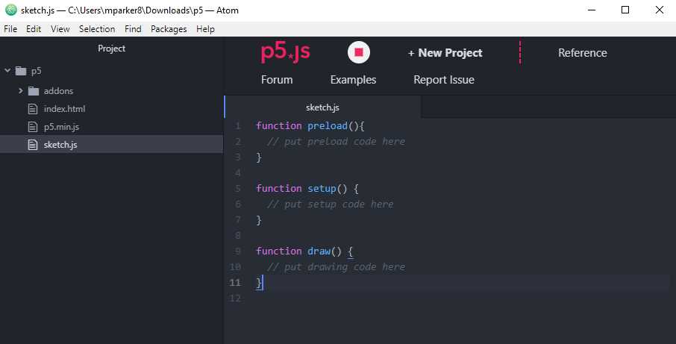

Note that createCanvas() and background() functions are missing, so students will need to add those back in! The preload() function can be ignored or deleted, unless students will be adding images or sound to their sketches.

Students may save their sketches using File → Save or CTRL + S, but note that this sketch will be saved *locally*, so they will need to use the same device in order to retrieve their work. If your students tend to use different devices, they should write their code down by hand in their design journals before the end of the lesson to save their work.

For Mac devices, you can follow [this video tutorial](https://www.youtube.com/watch?v=4Og4wS_gL30) to learn how to install the p5.js toolbar (make sure Atom is already installed).

For Windows devices, here are the steps to follow:

1. [Install](https://atom.io/) the Atom text editor
2. Open Atom, and click File → Settings
3. On the left sidebar, click on Install
4. In the search bar, type in p5js-toolbar (no dot between p5 and js)
5. Click the blue install button to add the p5 toolbar to Atom (see image below)

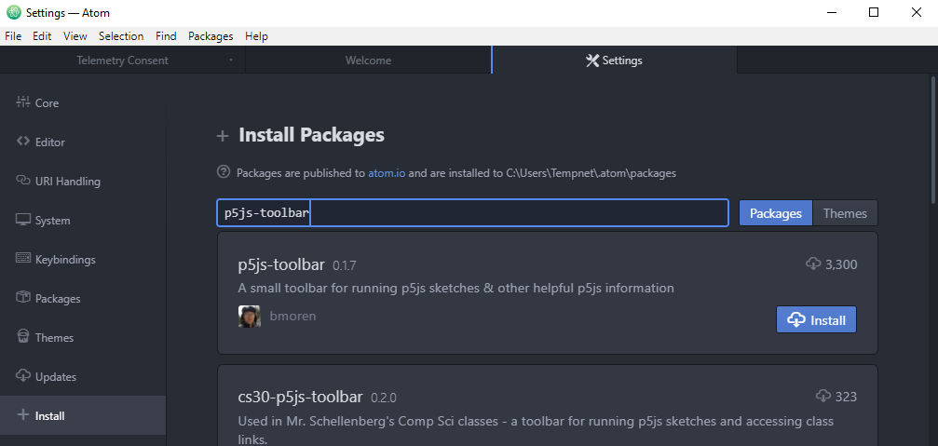

1. Once installation is complete, at the top of the screen click on Packages → p5js-toolbar → Toggle p5.js toolbar. This will add the p5.js toolbar to the top of the screen.
2. Click + New Project. You will need to select a folder in which to include the new p5 project.
3. This will create a new p5 project folder and sketch.js file. If the p5 toolbar disappears from the top of the screen, toggle it back on by following Step 6.